Hill climbing for n queens:
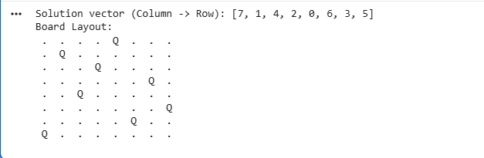

Simulated annealing for n queens:
